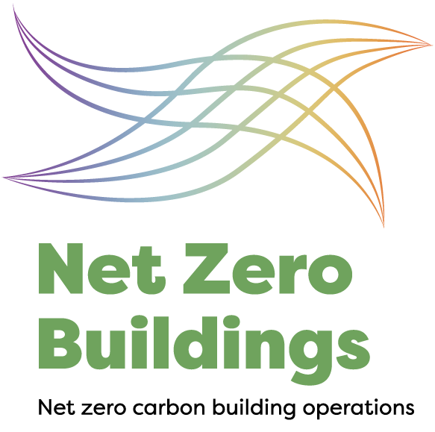
NEW ZEALAND GREEN
BUILDING COUNCIL
Email info@nzgbc.org.nz
Phone +64 9 379 3996
Web www.nzgbc.org.nz
Post PO Box 5286 / Wellesley St /
Auckland / New Zealand

Net Zero™ Buildings Certification Registration Form

Date

Building Owner (Applicant) Information

Organisation
Applicant Representative
Title in organisation
Applicant Address:
Contact number:
Email address:
Billing address (if different from above):

Applicant Agent (if applicable)
Organisation:
Title in organisation:
Contact number:
Email address:

Building(s) Information:

 | Building Name | Address | Floor Area (m²) | Primary Use(s)
1 |  |  |  | e.g. office, industrial, hospital
2
3
4
5
6
7
8
9
10

Eligibility Check

- Building Type
Please ensure the above table is completed, including primary use(s) to confirm that none of the buildings to be rated is a car-parking building, or single detached dwellings.
Is there any residential component within the building(s)? | Yes/ No
If the answer to the above question was “yes”, please explain:
- Timing of Submission for Certification
Have all buildings to be included in the rating been operated under normal conditions for at least 12 consecutive months? | Yes/ No
If the answer to either of the above questions was “no”, please explain:
- Distinct Boundary
Are all buildings to be included in the rating standalone, distinct buildings? | Yes/ No
If the answer to the above question was “no”, please explain:
- Minimum Occupancy
Are all buildings to be included in the rating “occupied” buildings (i.e. minimum 1 FTE occupant)? | Yes/ No
If the answer to the above question was “no”, please explain:
- Timing of Performance Period
What is the proposed measurement period for the project?  The “measurement period” is 12 consecutive months. This measurement period must commence no earlier than 15 months prior to registration and end no longer than 24 months post-registration. The project needs to submit documentation for assessment within 4 months after the end of the measurement period. | e.g. Aug 2016- Jul 2017
If unknown, I acknowledge that the measurement period must be identified within 90 days of the date of submission of this registration form. | Mark with “x” to acknowledge
- Other Requirements
I confirm that the registered premises comply with all Environmental and Occupational Health and Safety Laws | Mark with “x” to confirm
The building(s) will achieve at least 8 out of 20 points (base building) or 9 out of 23 points (whole building) in the ‘Greenhouse Gas Emissions’ Credit of Green Star Performance or at least 4-star NABERSNZ Energy rating. | Mark with “x” to confirm
I understand that upon successfully achieving the Net Zero Buildings Certification, a Public Report will be made publicly available with a summary of the Net Zero Buildings certificate. | Mark with “x” to confirm

Confirmation of Registration and Acceptance of Terms and Conditions of NET ZERO BUILDINGS Certification:

The Applicant agrees that this Net Zero Buildings registration confirmation forms part of and is subject to agreement to the Net Zero Buildings Terms and Conditions of Certification (the Certification). The Net Zero Buildings Terms and Conditions of Certification can be found on the NZGBC website.

The Net Zero Buildings certification assessment commences when NZGBC receives the registration fee.

☐ EXECUTION
I have read and agree to the Net Zero Buildings terms and conditions*

*by agreeing you give NZGBC permission to celebrate and publicise ratings achieved by this certification. Please let us know in writing at time of registration if you would prefer this information remained confidential.
IF THE REGISTRATION FORM AND ACCEPTANCE OF TERMS AND CONDITIONS IS ENTERED INTO BY AN AGENT OF THE APPLICANT, THE APPLICANT MUST COMPLETE THE FOLLOWING CONFIRMATION OF AGENTS AUTHORITY:

This Confirmation of Agent's Authority provided to the NZGBC will be effective upon receipt by the NZGBC of an executed copy (execution by ticking box below) of this form.

SCOPE OF AUTHORITY

1. The Applicant confirms that the Agent has been granted authority to act on behalf of the Applicant in relation to the Project.
2. The Applicant confirms that the Agent has been granted authority to complete this registration and accept the Certification Terms and Conditions in relation to the building (s) on behalf, and with the full knowledge, of the Applicant.
2. The Applicant understands that by providing this Confirmation, it will be bound by the actions of the Agent as if the same were taken directly by the Applicant.

REVOCATION OF AUTHORITY

1. The Applicant acknowledges that the NZGBC and its employees, agents, successors, and assigns will continue to rely on the representation of authority provided by this Confirmation unless and until the NZGBC receives written notice from the Applicant that the authority of the Agent to act on its behalf has been revoked, and the NZGBC provides notice to the Applicant of the receipt and acceptance of the termination of authority.

2. Any termination of authority only applies to the Agent's actions taken following NZGBC's acknowledgement of the termination of the Agent's authority.

☐ EXECUTION
The Applicant consents to all the provisions of this Confirmation.

Confirmation

I confirm that the information on this form is accurate and true.

Name:
Organisation
Title in organisation:
Date:

